1.Team Name

* Space Escape Simulator

2. Names for the members of the team

* Kayla Stultz, Tyler Beller, Adriana Gonzales, Lorenzo Pesina

3. Brief Description of your game

* A survival game taking place on an alien planet. The player will explore their surroundings, and die if they make the wrong decisions.

4. Simple User Manual

* Enter a command when the prompt displays on-screen. The possible responses will be provided.
* Fastest solution: type [EXPLORE, YES, RIGHT, RIGHT, IGNORE, TRY, 5927, NO]

5. Topics from the Solution Requirements List and their Location

* A class: Line 10(Class Satchel)
* Assignment statement: line 6
* Print statement: starting at line 23
* If statement: line 19
* While loop: starting line 18
* Flowchart or design: starting at line 109
* Recursive function: lines 171, 424, 580, 582
* List: line 4
* Set: line 2
* Tuple: line 7
* Dictionary: line 8
* Using +=, -=, etc.: starting at line 21
* 2 styles of comments: line 2, lines 11-12
* Nested if statement: starting line 27
* Nested loops: starting line 18
* A list within a list: line 5
* Random number generator: line 381
* Try/Except: starting line 240
* File reading: line 241
* File writing: line 244
* Using len with purpose: line 324
* For loop: line 281
* Function calling another function: starting line 183
* Function def with default parameters and function call: starting at line 157
* Function def with Parameters and function call: starting at line 449

6. A flowchart or design of the entire program

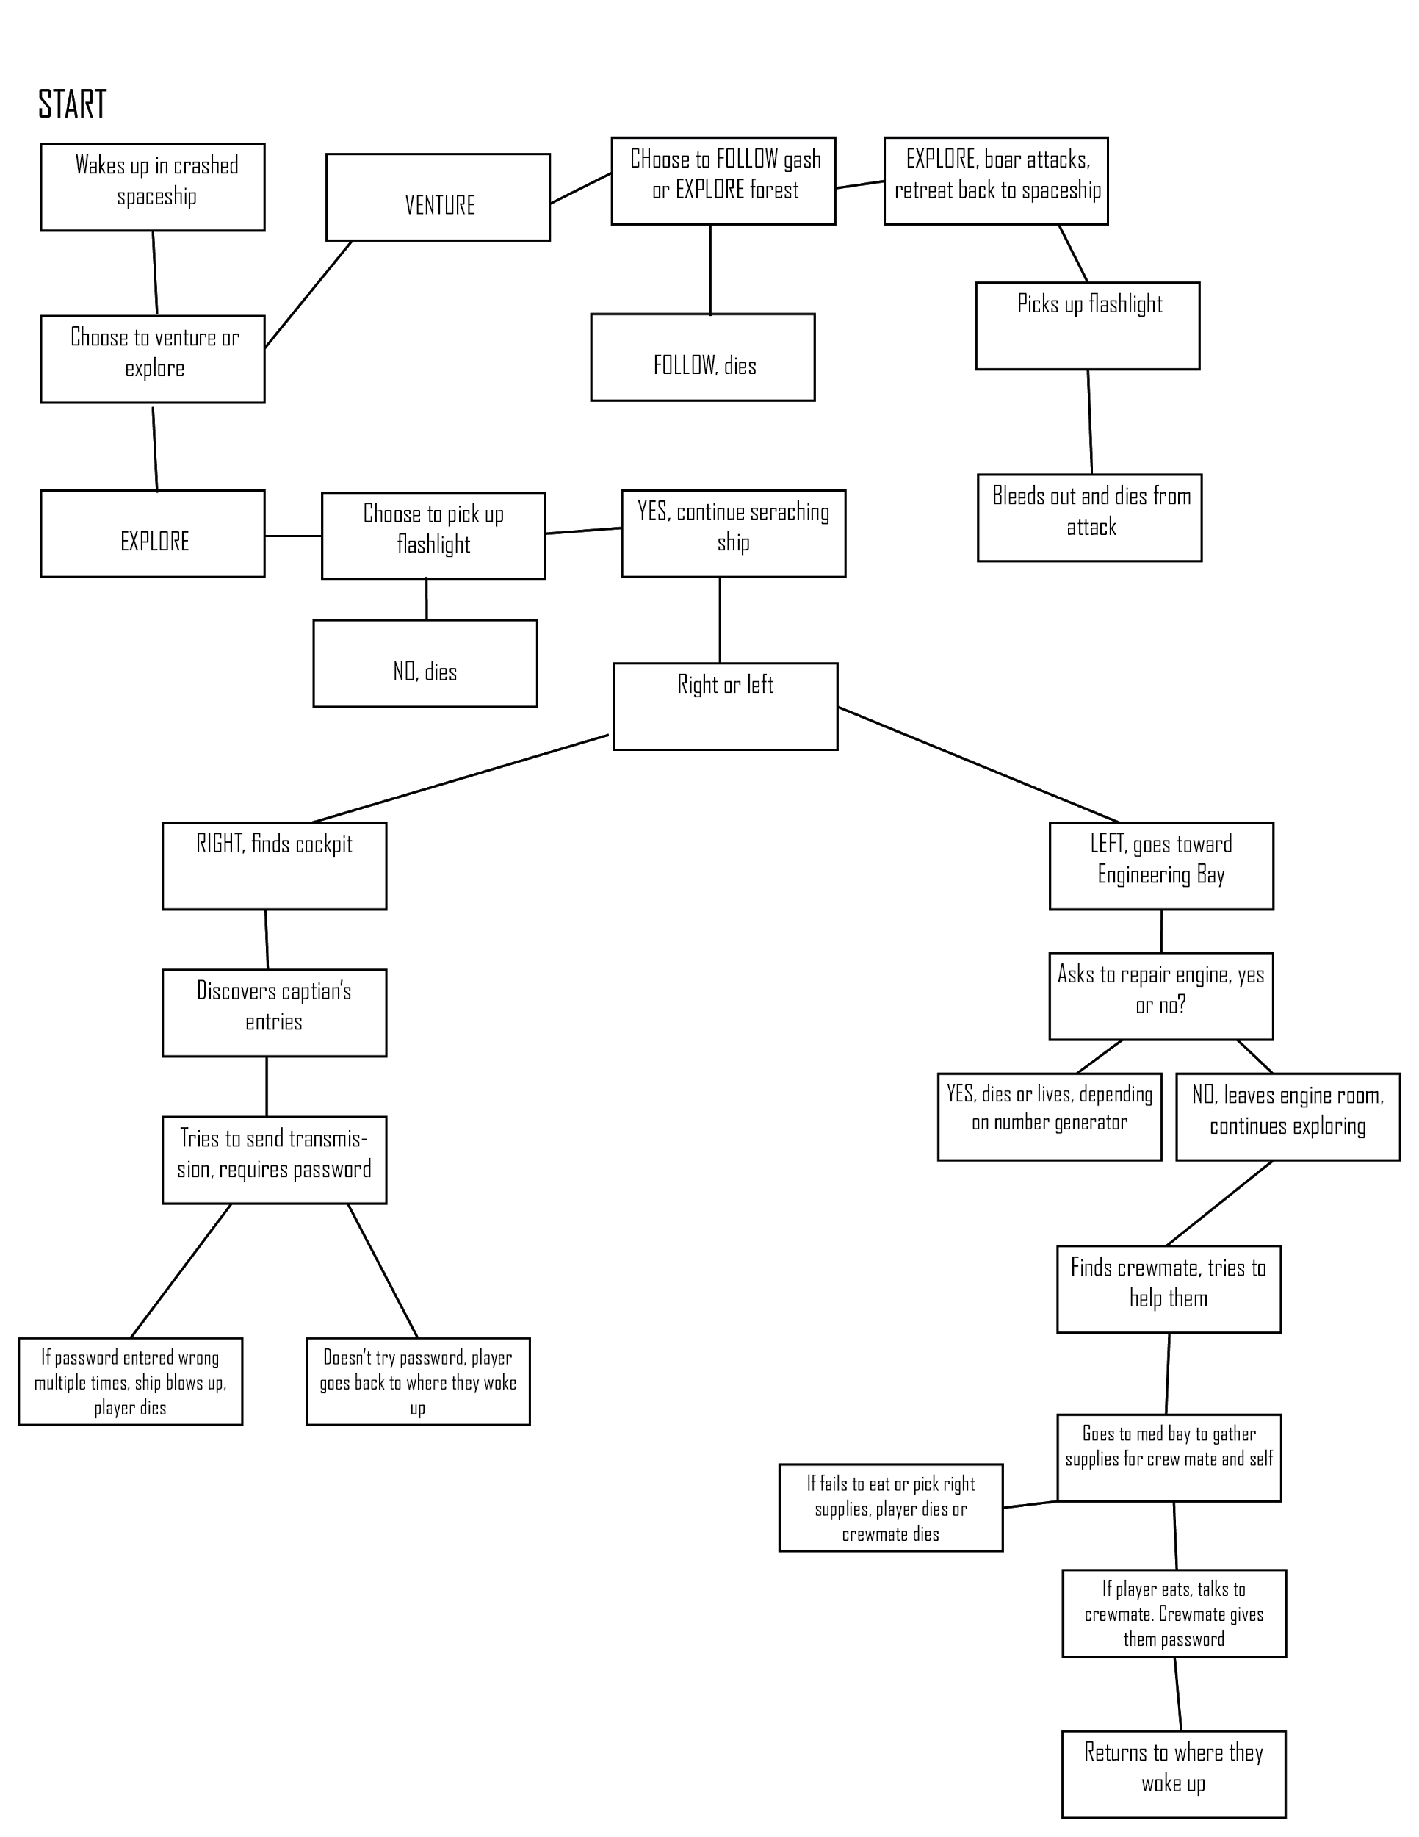

7. Any known errors or problems with your program

* There should be no known errors or problem with our code

8. Any messages to the instructor

* We have no messages for the professor